Annotated Code Document – Project 1
Code | Annotation
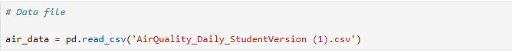 | This is us calling the raw data file
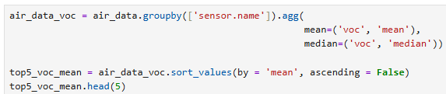 | We use the .agg and .sort_values function to narrow down and better organize our columns for ordering. By changing the “by = ‘mean’” to “median”  we can also see the data sorted by the median. You can also change ‘voc’ to any data column on the raw data file. Inside of the .groupby(), you can add multiple columns to view additional columns side by side
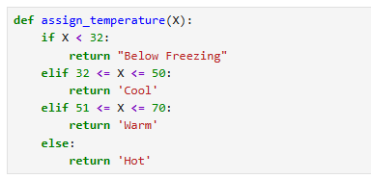 | By using definition loops, we can use Python to recognize values within a data set and assign additional characteristics. We can add multiple characteristics, such as colors as well to be paired with one singular range of values.
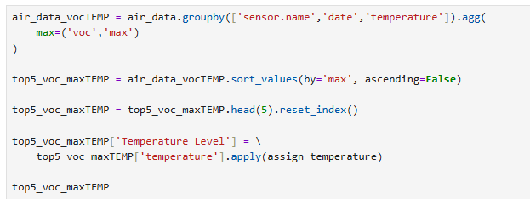 | Here we are calling our definition loop by adding a .apply(assign_temperature) to our code. This takes the temperature as defined by the variable, and labels it based on the characteristics defined above in the loop.

Some variation of the code demonstrated above is being used at all times.

